**SCHOOL OF INFORMATICS & IT**

**Storytelling Dashboard - Data Storytelling**

Student Name (Matric Number) : Javen Lai Le Yu (2202934B)

Tutorial Group : P03

Jenny LING (TP)

Tutor : Nami Imanishi

Submission Date : 9/12/2023

**Declaration of Originality**

I am the originator of this work and I have appropriately acknowledged all other original sources used as my references for this work.

I understand that Plagiarism is the act of taking and using the whole or any part of another person’s work, including work generated by AI, and presenting it as my own.

I understand that Plagiarism is an academic offence

and if I am found to have committed or abetted the offence of plagiarism in relation to this submitted work, disciplinary action will be enforced.

**Declaration on the use of Generative AI tools for assignments**

|  |
| --- |
| Describe how you have used Generative AI tools such as ChatGPT or Dall.E-2 in your assignment.  Show snapshots of the conversations with the AI tool (i.e., the prompts you used and the response you get from the AI tool). |
| ChatGPT Conversation:  <https://chat.openai.com/share/13170724-6507-4967-84b0-e70626f56f4c>  <https://chat.openai.com/share/1c247586-b164-4caa-9e41-73b346a6cbb6>  <https://chat.openai.com/share/c89ea149-c360-496f-b49a-669aa7b80b8f>  For this project, I used ChatGPT to phrase my statements and explanations to be clear and succinct:    I also clarified the project specifications to ensure I am not missing out anything:    **Quality check against rubrics:** |
| How do you indicate the reference?  The content generated by AI tools are not retrievable except by the user who generated them, so they are considered non-recoverable sources. Although non-recoverable data or quotations in APA Style papers are usually cited as personal communications, with ChatGPT-generated text there is no person communicating. Quoting text from ChatGPT chat is therefore more like sharing the output of an algorithm, with a reference list entry and the corresponding in-text citation.  According to the official APA Style site, ChatGPT references should be cited as:  E.g. OpenAI. (2023). *ChatGPT* (Sep 25 version) [Large language model].  <https://chat.openai.com/chat> |

**Important Note:**

* Do not copy answers produced by the AI tool in totality as it is considered as plagiarism.
* Do not rely on any information produced by the AI tool blindly. You should always verify the answer with other sources. Do not assume that these answers provided by the AI tool are correct.
* To achieve quality outputs from the AI tool, you should provide good prompt that is clear and specific. Be precise and provide context. Avoid asking open-ended questions.

**Task 1 : Visual Cues**

1. **Colour and Contrast + Visual Hierarchy + De-cluttering**

* Reselected a more **pleasant colour scheme that contrasts better**.
* Employed an **ordinal colour gradient to show a clear conventional visual hierarchy** of good, medium, and poor ratings.
* Having too many ratings clutters the bar chart, making it overwhelming. To **declutter and enhance clarity**, the ratings are grouped into Ideal (5), Moderate (3-4), and Poor (1-2) clusters.
* Enquiry is too specific for non-technical viewers to interpret. Hence, I will group them into a broad and generic category so that business users can instantly identify common inquiry types from a glance and only investigate deeper into a particular inquiry if they want.

**Before: After V1 (Used in Dashboard):**

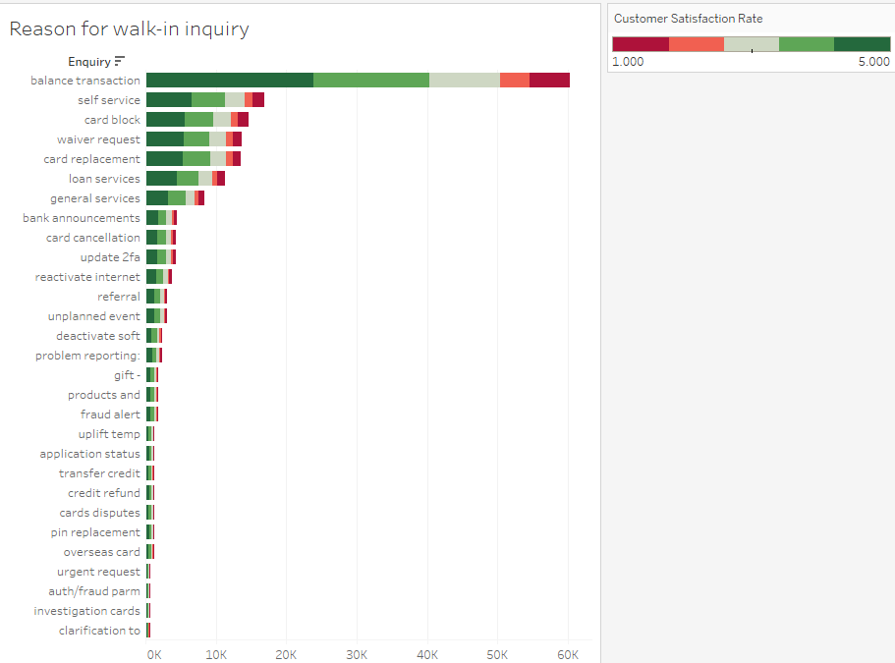 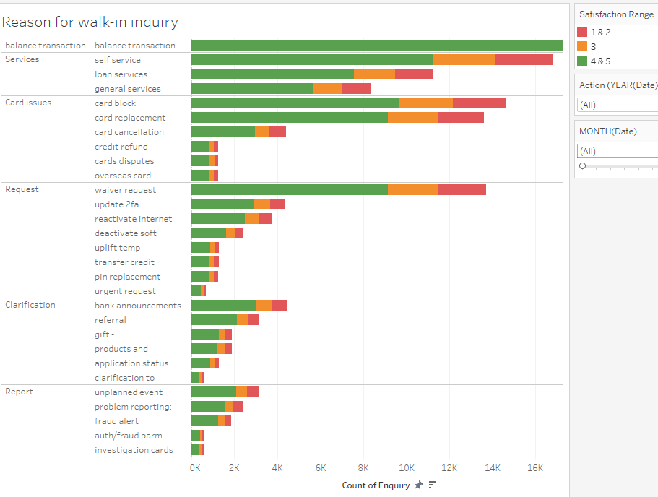

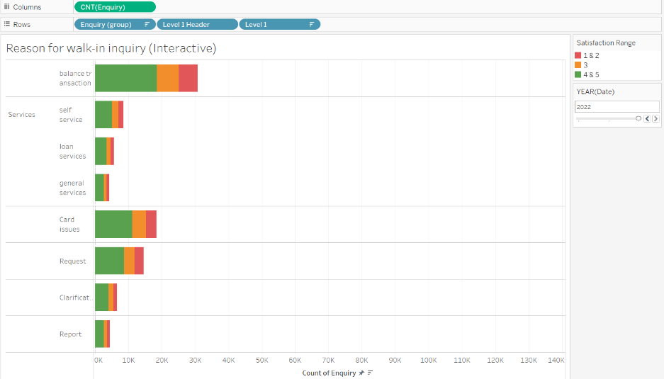**After V2 (For Storyboard):**

I created a version that only displays the inquiry type and aggregates all the inquiries within the inquiry type to **declutter** and create a clear and direct overview of each inquiry type.

The user can still drill down to inspect an inquiry in an inquiry type by clicking on the bar to expand.

Info:

* Blue square: shows the improvements made to the graph.
* Orange square: To show how the user can drill down an inquiry type by clicking to expand, to highlight certain inquiries.

1. **Changing visualization to show comparison + highlight + annotation**

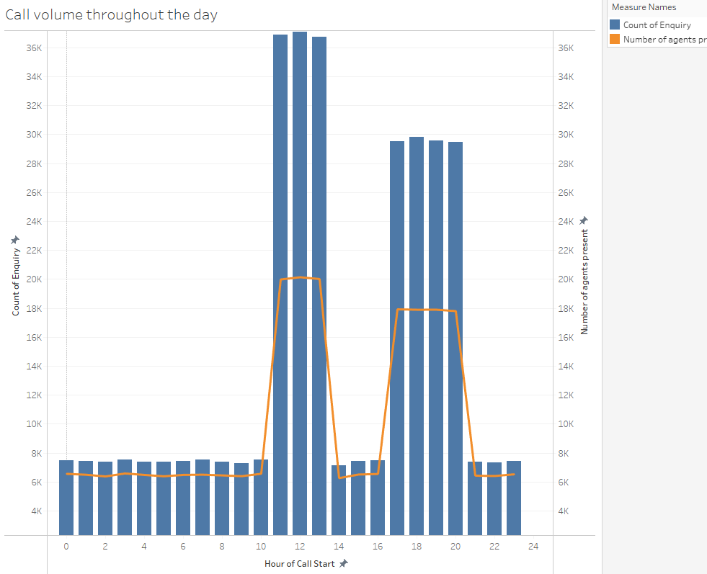 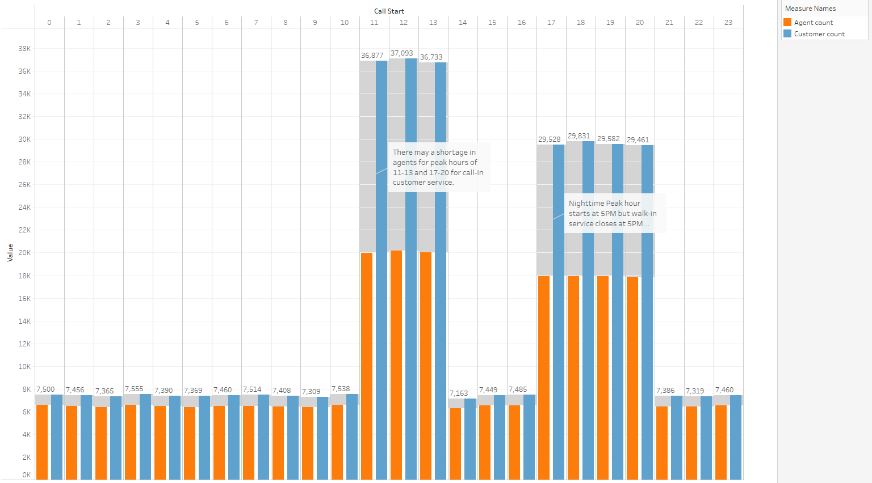

* **Changed visualization to a dual bar chart to clearly display a comparison** between the availability of agents and customers.
* Repicked **colours that contrast well** to represent agents and customers to be **colourblind inclusive** by making the bars easy to differentiate.
* **Highlighted difference** between agents and customers to enable a direct comparison of how wide the difference between the agent and customer bar is, enabling the reader to intuitively tell that there is a shortage of agents in certain hours.
* **Labelled** the number of customers for each hour for easier readability and **annotated certain hours with insights** that the graph intends to bring out to ensure the reader will not miss any insights from the graph.

**Task 2: Dashboard**

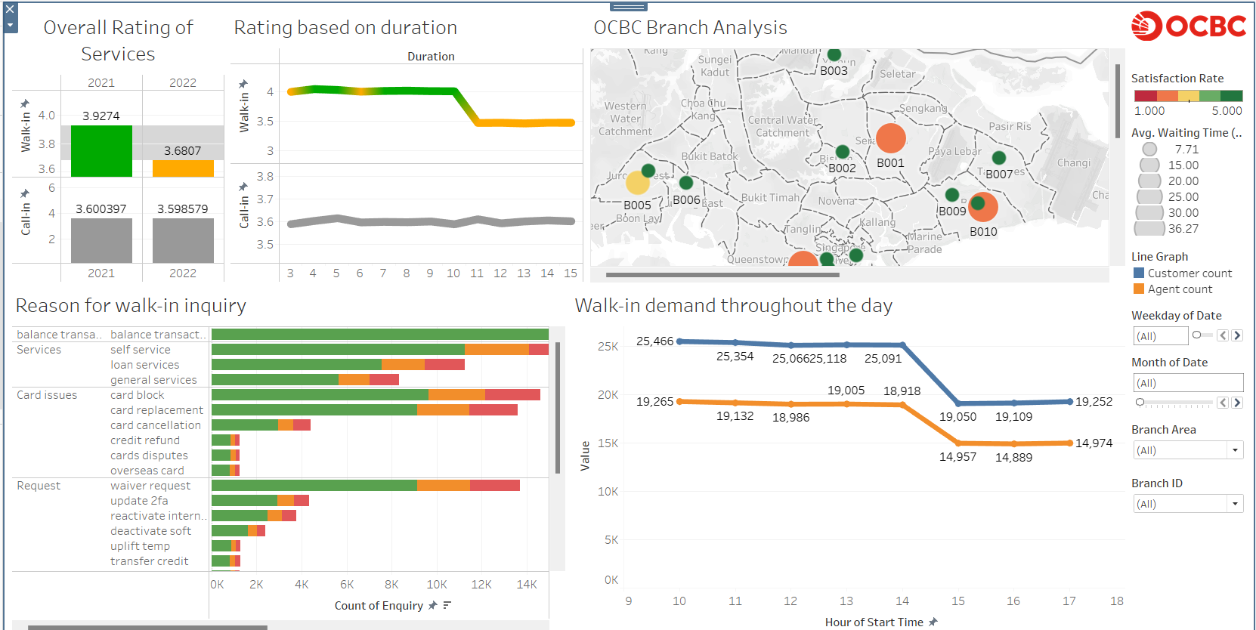

**Considerations**

|  |  |
| --- | --- |
| **Consideration** | **Implementation** |
| Professional design to match OCBC’s style | Using plain white wallpaper, added the OCBC Logo to signify Dashboard is regarding OCBC performance. Legends and filters are **placed orderly** on the right to keep the dashboard clean and neat.  Used the same font, font-size, and sticked to a few colours for **consistency**. |
| Placement of charts for readability | The dashboard is **strategically designed for left-right, top-down reading**, which is why the **hook is placed at the top-left to ensure it's the first thing the readers see**. **Top** **3 graphs provide an overview context** about the performance of OCBC service in general, while the **bottom 2 graphs delve specifically into factors** affecting walk-in performance. The most interesting graph is placed at the top right. |
| Ease of interacting with map to derive insights | The interactive map is placed top-right because it’s the most interesting graph and considering that most readers will be right-handed. This strategic placement enables ease of exploring the map since the User must hover over a branch to uncover insights from the tooltip. |
| Visual Cues: Visual Hierarchy + Highlight | 1. Highlighted difference between performance for walk-in (top-left graph) to ensure readers can tell that there is a significant performance drop.  2. Every colour has a meaning to facilitate intuitive interpretation.  - Graphs lacking important patterns (not main focus) are in grey to avoid attention.  - Employed ordinal green-red colour gradient to enable intuitive interpretation of performance. Green represents good, yellow-orange represents average, red represents bad.  - Orange and Blue in Line Graph (bottom right) indicate the measure they represent. Orange and Blue are chosen as they contrast well and are inclusive to colourblind readers. |
| Communicating with readers | 1. Every graph has clear titles and axes for user comprehension, to ensure the purpose and message of each graph can be communicated clearly to the user. 2. Labelled values on certain graphs making it faster for readers to derive insights as they don’t need to read the axis to find the value for each point of the bar/line chart. 3. Stretched (to make the scale drastic) the y-axis of the 2 top-left charts to as this attracts reader’s attention that there is a trend in the graph and ensures they will notice the insight of a significant drop in performance from 2021-2022. |
| Usefulness of insights from graphs | 1. Top-left chart is a hook to induce urgency by highlighting the drastic performance drop to instill a sense of purpose for readers to uncover what caused the drop using the dashboard. 2. Top-middle chart reveals clear insight into how duration affects satisfaction rate. This insight is needed to answer the business requirement of finding factors that lead to poor ratings. 3. Top-right is an interactive map chart to allow users to explore performance for each branch and investigate how factors of different branches lead to performance changes. 4. The bottom-left chart can be used to study the volume of inquiries that OCBC receives. This allows insights like identifying the most common inquiry types and if there is any issues (such as prevalent poor ratings) for any inquiries. This insight is needed to answer business requirement of finding most common inquiry. 5. Bottom-right chart to analyze the demand for walk-in inquiry throughout the day, to understand the demand of customer service and identify peak hours for service (as required by analysis) and potential manpower shortage issues. |
| User friendliness | 1. Intuitive ordinal colour gradient that matches conventional understanding where green is good and red is bad. 2. Used line graph for time-series, to show sequential progression. 3. Used bar chart to allow reader to intuitively gauge each bar (longer bar means more) and compare difference with another bar. 4. Used size to represent length of waiting time for map, making it intuitive to make out what the size of a dot represents. 5. Legend to let the user know what the colours and elements represent. 6. Used elements like highlights and labels to help readers see values and insights directly and clearly (don’t have to read the axis and calculate). 7. Customized my filter components to make intuitive for its purpose of analysis E.g. Slider filter for weekdays months to analyze how trends of graph change over time, Single select for branch and branch area so that user can quickly filter and investigate a particular branch at a time. |
| Interactivity | 1. To enhance usefulness, I added filters that apply to all the charts, to make the Dashboard interactive for users to delve deeper and explore how the trend of inquiries, demand of consultations, etc. change over the years/months. 2. The charts can be filtered using a chart. E.g. click on a bar in a graph to focus on particular inquiry. This added interactive allows for in-depth insights to be discovered. E.g. how trend changes over time, is there an issue in a particular month. 3. The map chart is designed for exploratory data analysis, requiring user to interact by hovering over a Branch to discover more insights. |

**Task 4 : Big Idea, Linear Storyboard, Narrative Framework**

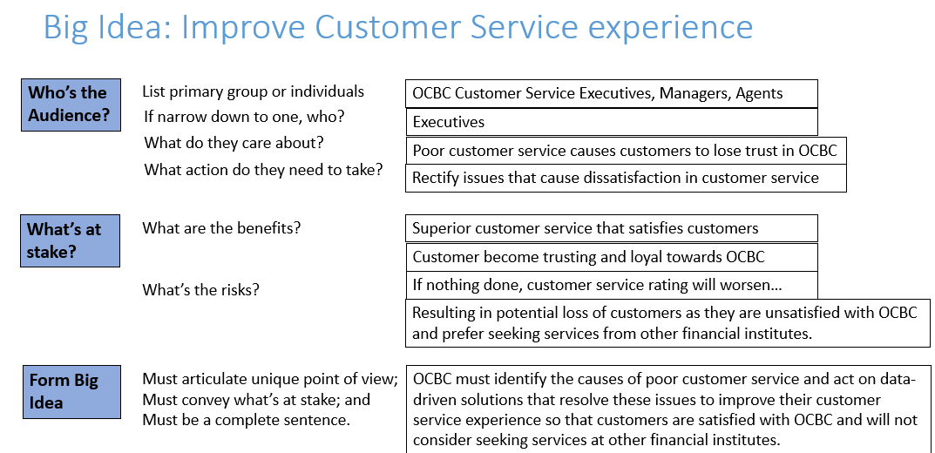

**Action**: Need OCBC Executives to approve and implement recommendations from my analysis to improve OCBC customer service.

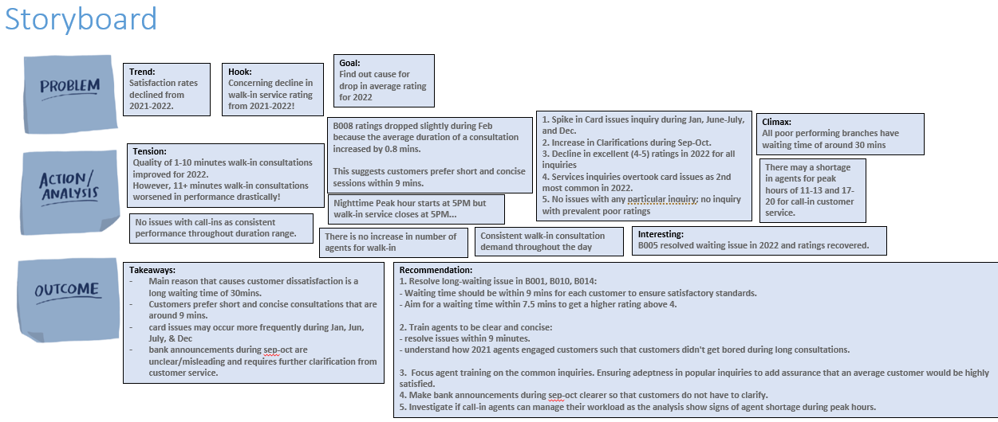

**Narration Framework using Freytag’s Pyramid:**

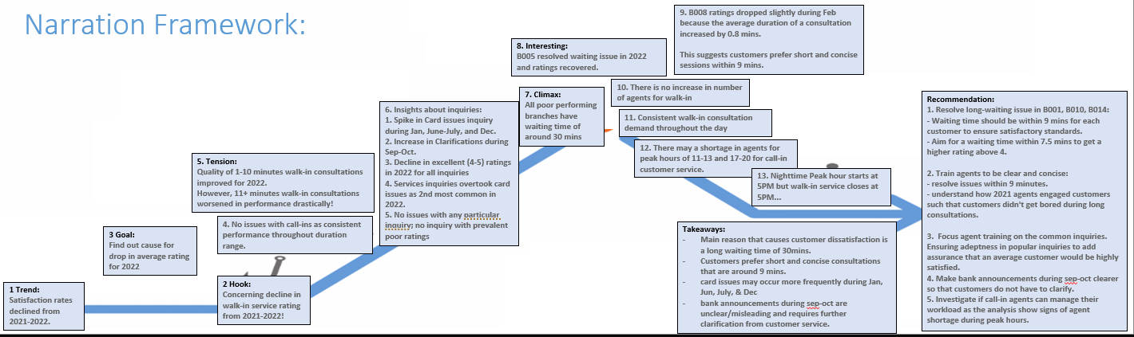

**Tension for the Audience**

Significant decline in OCBC's satisfaction ratings, especially in walk-in service. The fear of potential consequences if this trend continues adds to the tension.

**Resolution of Tension**

To resolve the tension, the analysis suggests a focus on identifying the key factors contributing to poor walk-in performance, aiming for a comprehensive understanding.

The investigation aims to uncover factors and patterns of poor ratings and determine the best course of action to improve satisfaction rates.

**Content**

1. **Introduction:** Satisfaction rates declined from 2021-2022 (Trend). Emphasize on drastic drop in performance from walk-in. Add sense of urgency by scaring reader with what will happen if trend continues (Hook). Purpose of investigation to let reader know what the story is about and what they can expect to get out of it (Goal).
2. **Inciting Event** (Tension): Show the significant disparity in walk-in performance across consultation duration, to highlight that analyzing walk-in should be the main focus of investigation as there is an issue, whereas there is no noticeable issue with call-ins.
3. **Rising Action**: Explore and explain how certain factors influence ratings, to build up to the most interesting insights at climax.

* No issue with any particular inquiry.
* Card issues common in Jan, Jun, July, & Dec.
* Clarification during Sep-Oct.

1. **Climax**: Most exciting and interesting insights, such as factors that significantly impact ratings.

* All poor performing branch have a long waiting time above 30 mins.
* Performance drop in all branches (except B005) in 2022 despite a slight reduction in average waiting time for branches.
* B005 resolved long waiting time issue and ratings improved during 2022.

1. **Falling Action**: Recap to emphasize important takeaways. Extra analysis to further support existing takeaways to ensure all claims in recommendations are valid and fully backed with concrete evidence.

* Summarise findings and setup for resolution (Takeaways).
* Analyse demand for customer service throughout the day to answer business requirements where peak hours should be identified.

1. **Recommendation + Call To Action (CTA)**:

* Relevant recommendations from analysis to improve OCBC service ratings.

Compelling CTA urging readers to act on the recommendation to protect what’s at stake.

**Task 5 : Tableau Story**

**Decrease in walk-in performance (Introduction)**:

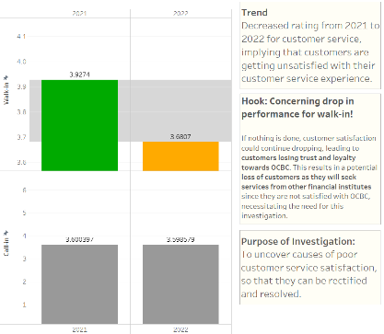**Give context**, to get readers interested and know what they can gain from the story. Follows Freystag’s pyramid: contains the current trend, a **hook** (with a visual aid of exaggerated bar chart that amplifies the drop) to express the severity of the issue, to add a **sense of urgency** by telling what could happen if nothing is done to address the issue. I used a bar chart to show a drop in performance as visuals to support my claim.

Finally, I list the **purpose of this investigation** to let readers be clear on what this story is about and how it benefits.

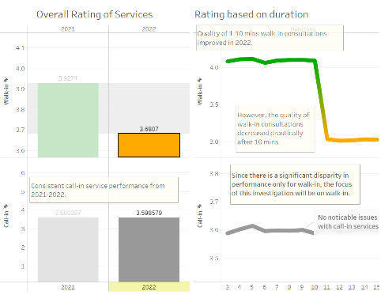**Performance across duration (Inciting event):**

1. Long duration leads to a sharp drop in performance for 2022 as seen in line chart. First 2 **page answers ‘if OCBC customers are currently satisfied with our service’**.

2. Justify why the story focuses on walk-ins because there is no reason to investigate call-ins since the performance is consistent with no issues.

*This graph is interactive where the reader can click on the bar of the year to change the trend of the duration accordingly.*

**Why I must investigate further + Foreshadowing what analysis I will do (Rising Action):**

Build-up rising action by explaining what I plan to investigate, in a sequential manner, to ensure the story flows as I have not found the true drivers of poor satisfaction ratings yet. I also hinted what I will analyse ahead, to let readers know what to expect to create flow.

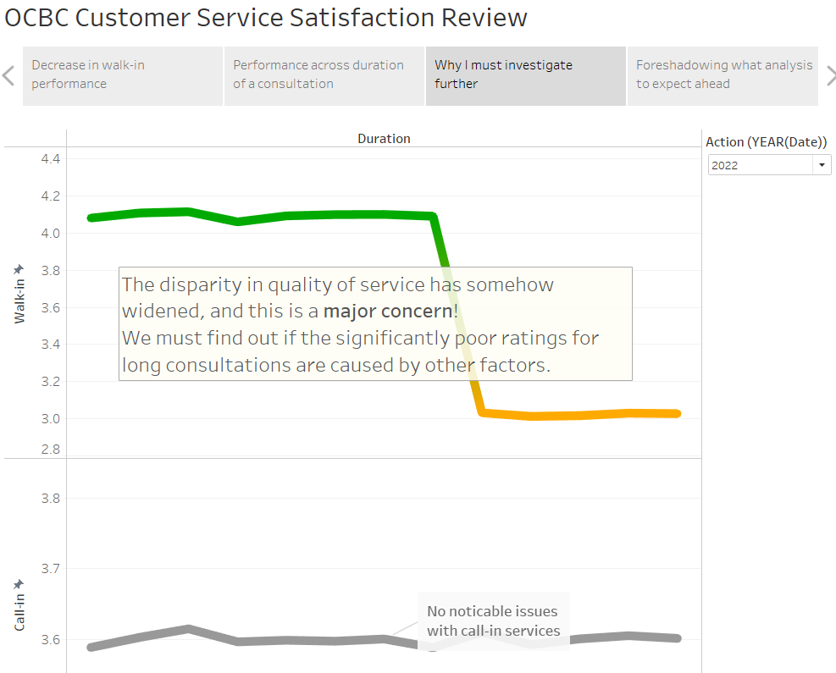 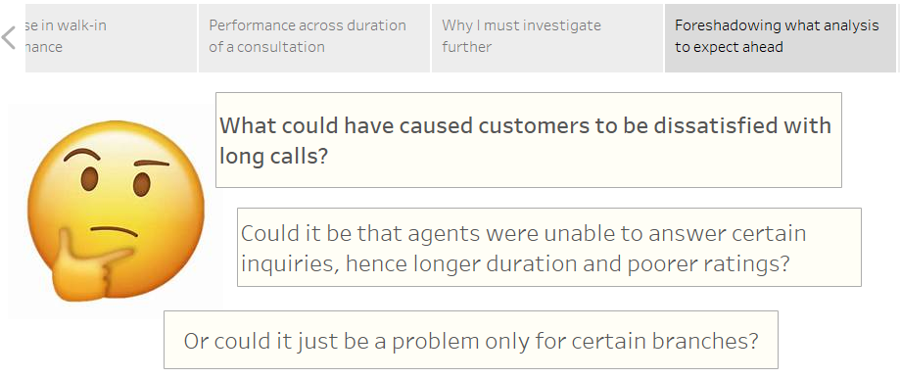

**Investigating satisfaction for various inquiries (Rising Action):**

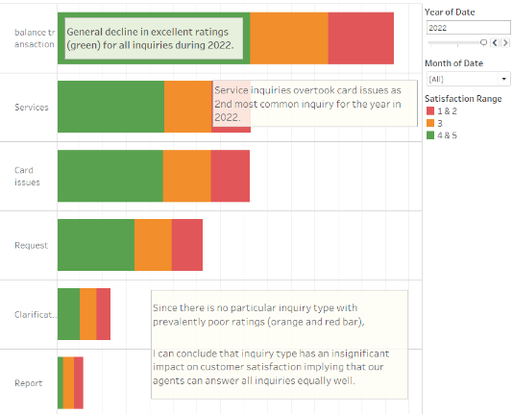Explained insights into common inquiries and how the performance of all inquiries dropped in 2022 using an interactive year filter. This bar chart is interactive as it allows reader to expand and drill down into an inquiry type when clicking on the header. Insights on this page are general, allowing for a comprehensive understanding without delving into specific inquiry types. This **chart reveals the ‘most common reason(s) for branch visits’** clearer as the longest bar is placed on top and represents most common inquiry.

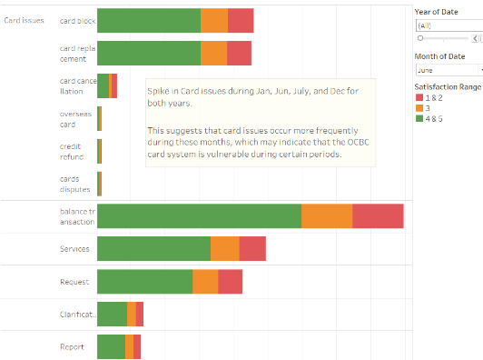**Rise in card issues (Rising Action):**

Filtering to June, card issues is most common inquiry. Drilled down to card issues graphs to show that the issue is mostly card block and card replacement. This insight is separated to utilize a visual that directly shows card issues as top inquiries for the month to better illustrate the insight, instead of asking readers to configure themselves to see. This delves into how the most common inquiry changes across the months.

Reader can interact with the interactive bar chart by clicking on an inquiry type to expand and find out all the inquiries within that inquiry type.

Reader can also hover over each green, yellow, red bar to get the exact count.

Finally, they can use the filter to explore trends across different periods.

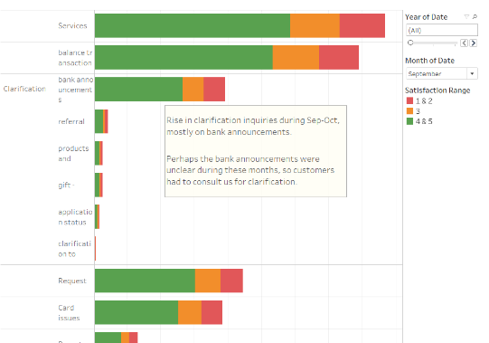**Rise in clarifications (Rising Action):**

Filtering to Sep and Oct, I noticed a rise in clarifications for both years. Drilling down into clarifications, the inquiry that led to the increase is bank announcements.

**Why I will investigate branches (Build up Climax):**

About to reveal the key factor that leads to poor ratings, so this page **adds flow to the story** by stitching rising action and climax by showing why the story progresses from A to B.

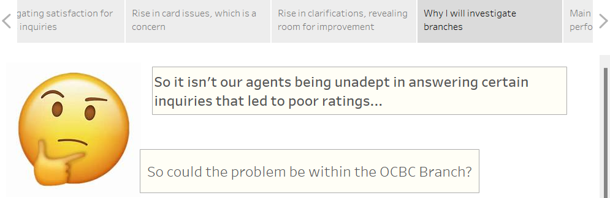

**Main reason for poor performance of Branches (Climax):**

Show the story of how ratings changed from 2021-2022 for each branch. This graph is **meant to be interactive** where customers must hover over a dot to uncover facts and derive **deeper insights into each branch from the tooltip**.

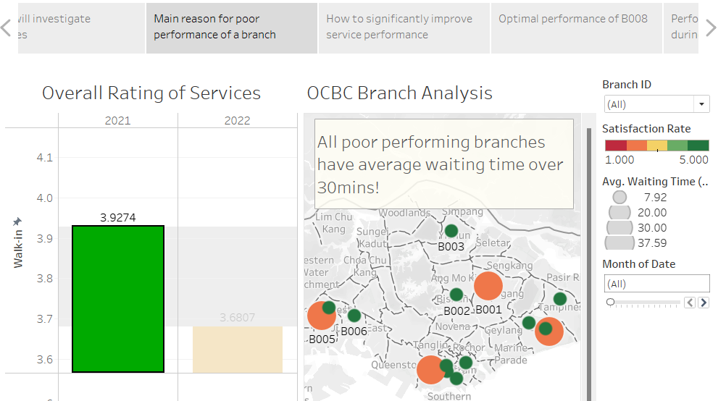 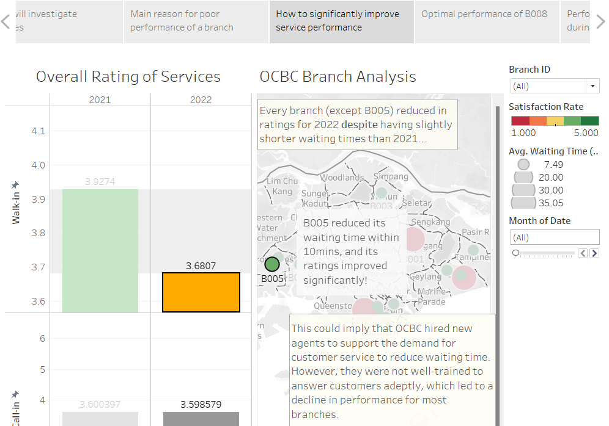

Reader can filter using the bar for the year and month filter, and hover over each branch’s dot to read the features of the branch during that particular period and compare with others to discover patterns and interesting insights on how the various factors affect the rating.

The 2 pages above answers: ‘Identify factors that affect rating score and explain how they influence the score’. For page 2 (right), I highlighted B005 and created an annotation to ensure readers will notice this insight.

**Optimal Performance for B008 (Climax):**

To make it intuitive for the reader to notice the insight I’m showing, I **highlighted the 3 branches to focus on, excluding the rest** of the branches, and used the month filter to show how B008 changed over time. B007 is used as support since its pattern change is similar to B008. B009 is a control to show that the trend only applied to B007 and B008 because of the pattern change. I added annotation to B008 to save readers the hassle of hovering over the branch to see the details so that readers can easily focus on the details and see the insight that an increased duration caused a reduced rating.

These 2 pages clearly displays the difference between Jan and Feb for B008 from the annotations and even has explanations, making it impossible for a reader to miss the insight these 2 pages intend to show.

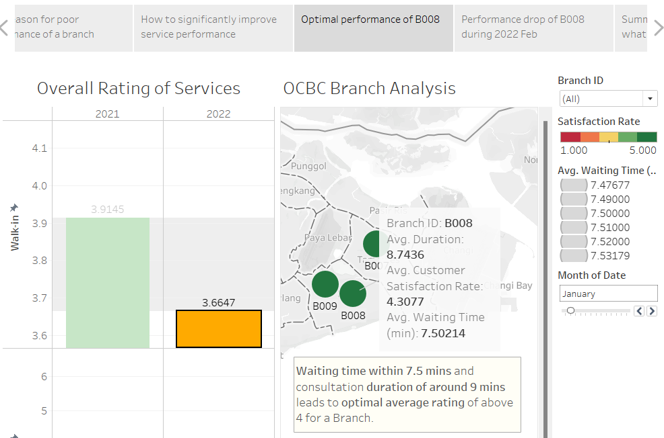 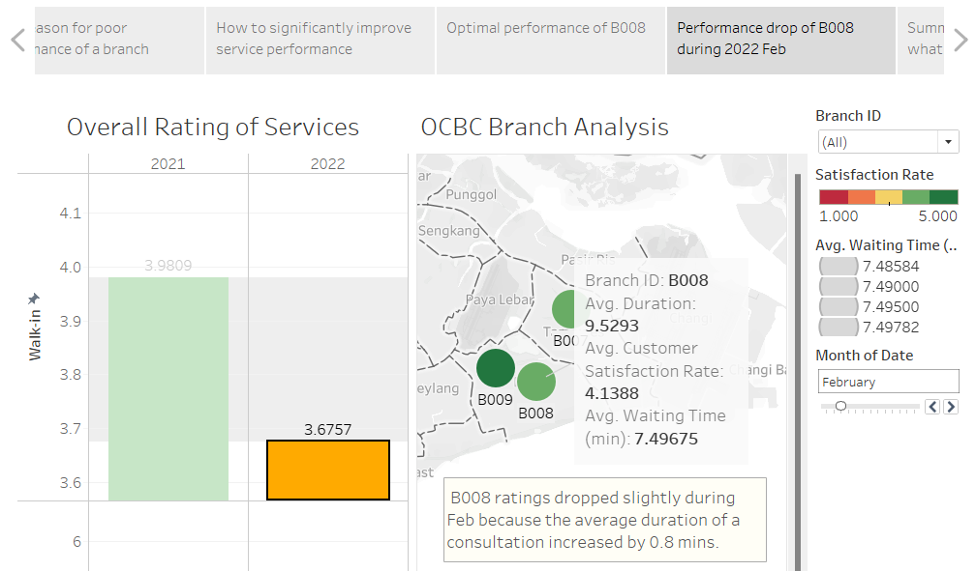

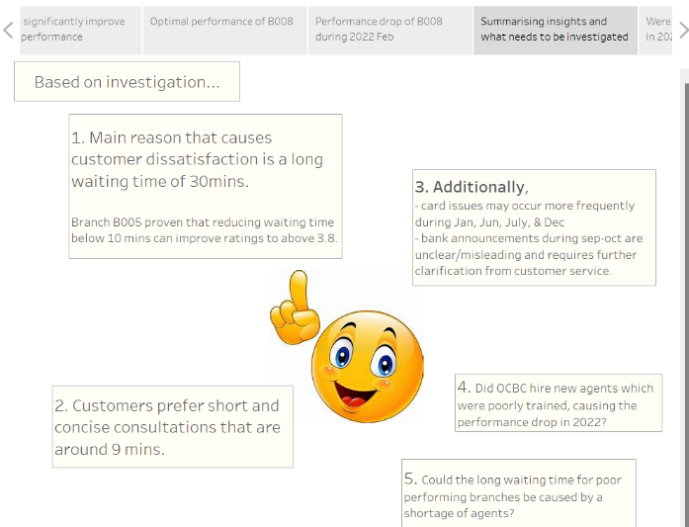**Transitioning to Falling Action:**

Since I already revealed all the exciting insight of the most impactful factors on customer satisfaction, **this part is a** **summary** to recap the reader on what they should have picked up from the story so far. I have **not addressed peak hours of customer service and any insights on call-in which are required** of this analysis. Hence, I had to **weave in a reason for me to explore the demand of customer service across the day** to ensure all needs of business requirements are fully answered.

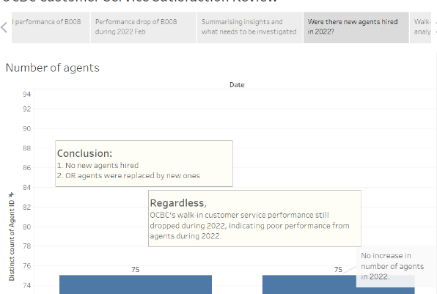**Were there new agents hired in 2022 (Falling Action):**

To concretely prove that there is no increase in agents during 2022, to facilitate the derivation of conclusions on whether the reduced waiting time in all branches and customer satisfaction drop could be caused by new agents is a valid claim.

This chart makes it easy to derive the insight that there is no increase in agents as bar for both years are on the same level with the same label value indicating they have the same count.

**Service demand analysis for walk-in and call-in (Falling Action):**

These 2 **pages answer the 2 business requirements**: ‘Identify peak periods when both call-in and walk-in channels experience the highest activity’ and ‘Identify if there is a specific time when a channel is preferred over the other and why’.

Analysis and insights from these 2 **pages help reinforce my claims before concluding my analysis** by proving that the performance drop is not caused by manpower shortage, which is why it's placed at falling action right before my resolution. I connected the analysis of call-in demand after the walk-in demand analysis by justifying why I should analyse call-in too. This ensures that the page will still flow logically in my story.

To derive insights on whether there is a shortage of agents, the reader can compare the difference between the blue and orange line/bar. To identify peak hours, the reader can clearly see which hour (x-axis) is significantly higher than the rest. For walk-in, reader can use filter to examine the trend across weekday and year, to derive insight that walk-in is closed on Saturdays.

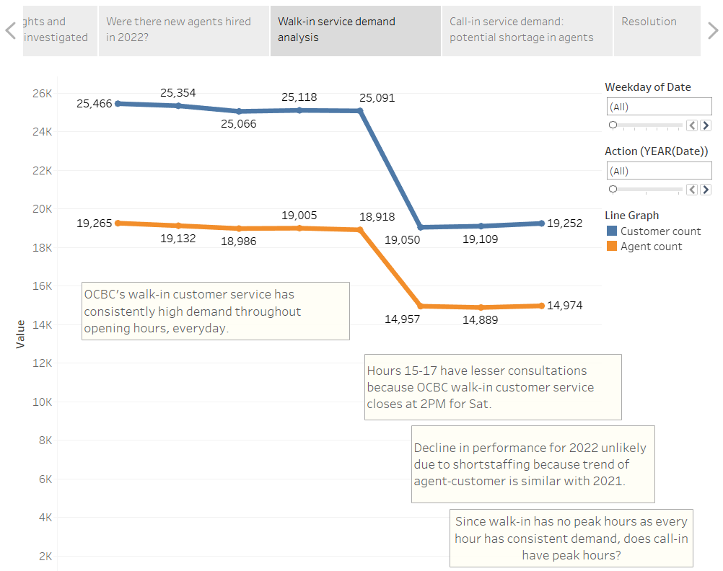 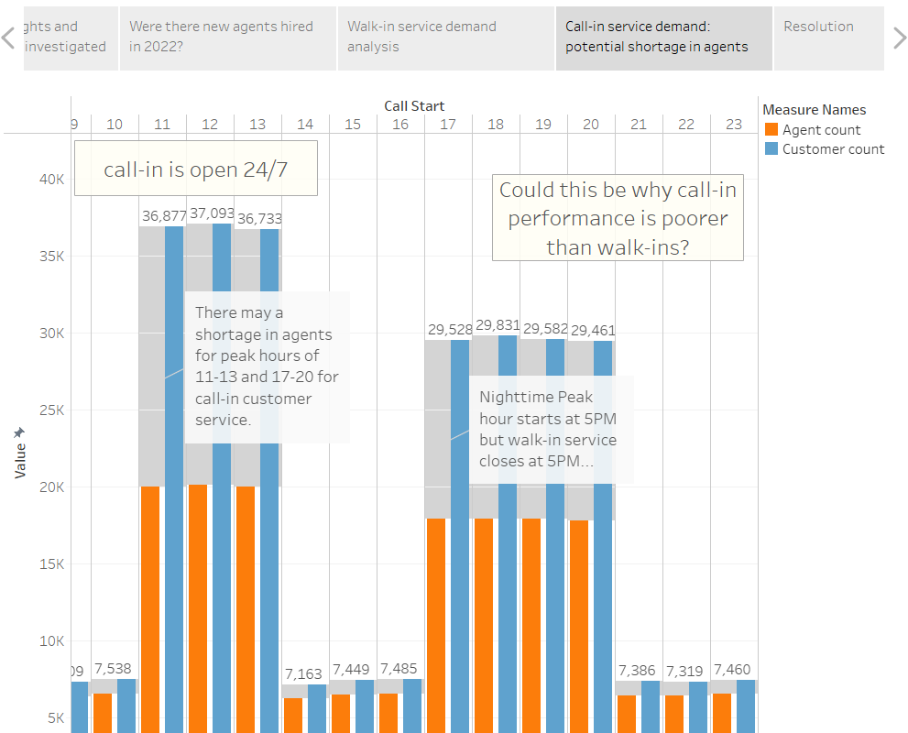

All business requirements from the problem statement are addressed, which means I can end the story now as all aspects of business needs are covered. I will end the story with a resolution that contains recommendations that are relevant to help improve customer service at OCBC.

**Resolution:**

Relevant takeaways and recommendations from the story that answer the purpose of the investigation and can be implemented to improve customer service performance. Includes Call to action to remind the reader (OCBC Executives) to consider taking the recommended actions in case they forget the problem and the need to action. Also had to make CTA convincing enough to compel the urgency to act as soon as possible to protect what’s at stake before it's too late.

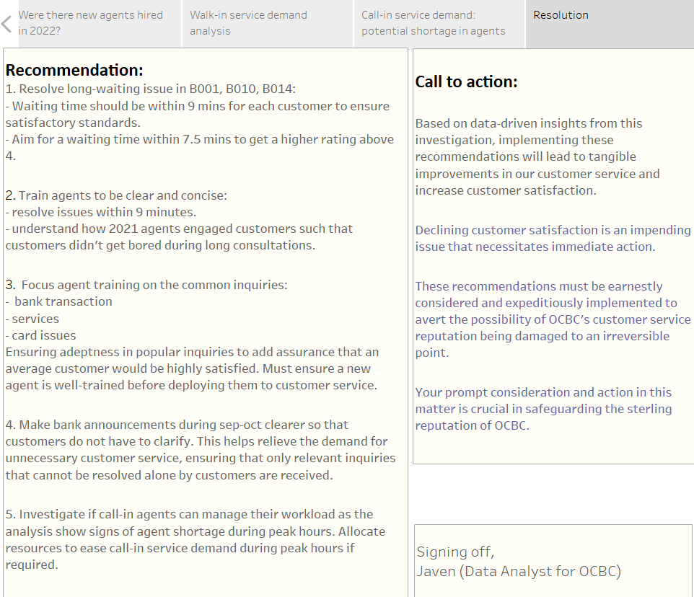

**End of Report**

**References:**

Interactive bar chart that can expand and collapse - <https://www.youtube.com/watch?v=b4KfAx2jSis&t=167s>

Dashboard designing principles - <https://www.datapine.com/blog/dashboard-design-principles-and-best-practices/>

Research on Freystag’s Pyramid - <https://www.masterclass.com/articles/freytags-pyramid>